11.47: Let 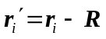,where 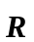 is the vector from the point O to the point P.
The torque for each force with respect to point P is then 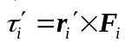, and so the net torque is

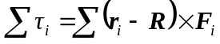
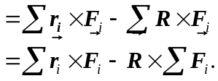
In the last expression, the first term is the sum of the torques about point O, and the second term is given to be zero, so the net torques are the same.

